What will be the output?

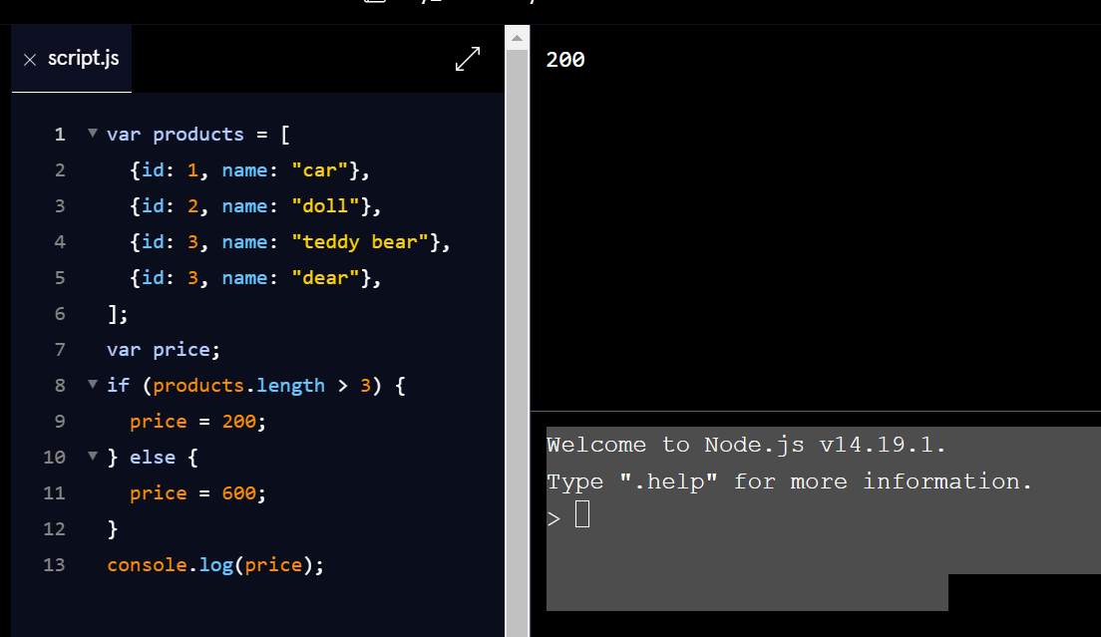

The output is 200. The length property is used to determine the number of elements in the array, if greater than 3 price is 200 else price is 600

**What will be the output of the following code?**

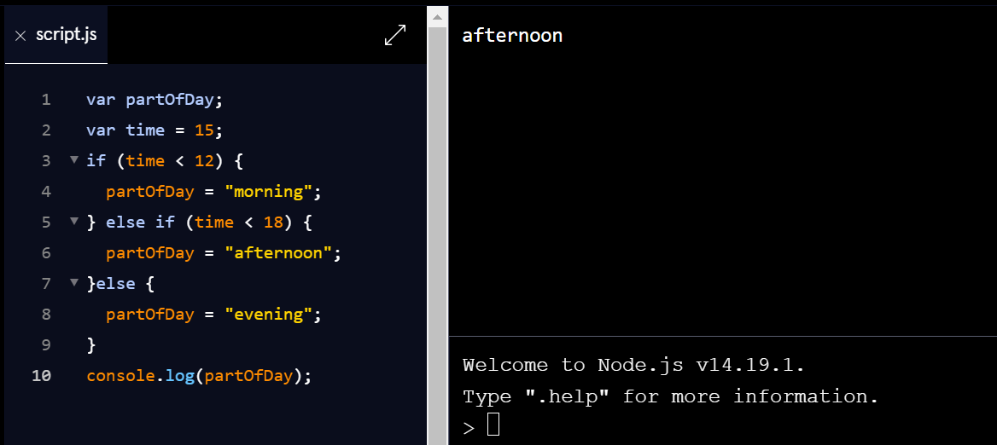

The output is afternoon as 15 is not less than 12 to make a morning but its less than 18 therefore afternoon.

**What will be the output for the code below?**

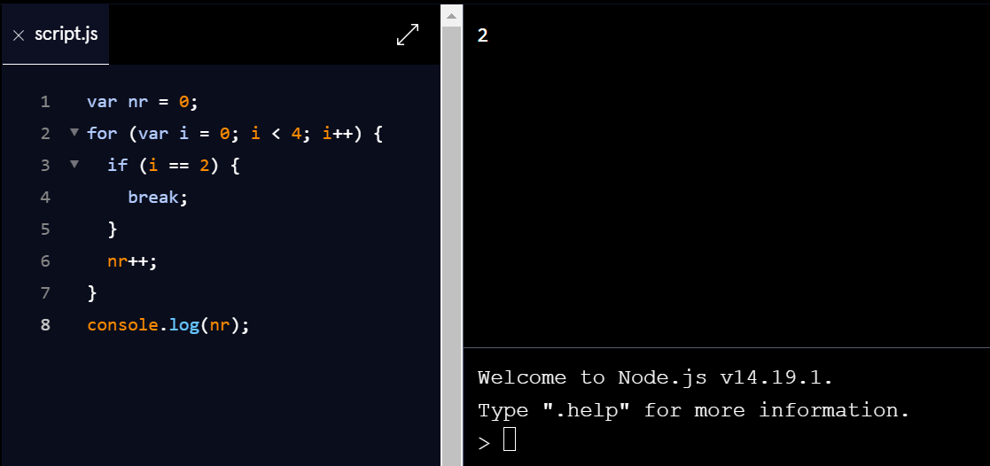

The break statement ends the loop. The variable nr is incremented in the first (i=0) and the second (i = 1) interactions. Then the loop ends in the third iteration (i = 2)

How many times will the console.log executed?

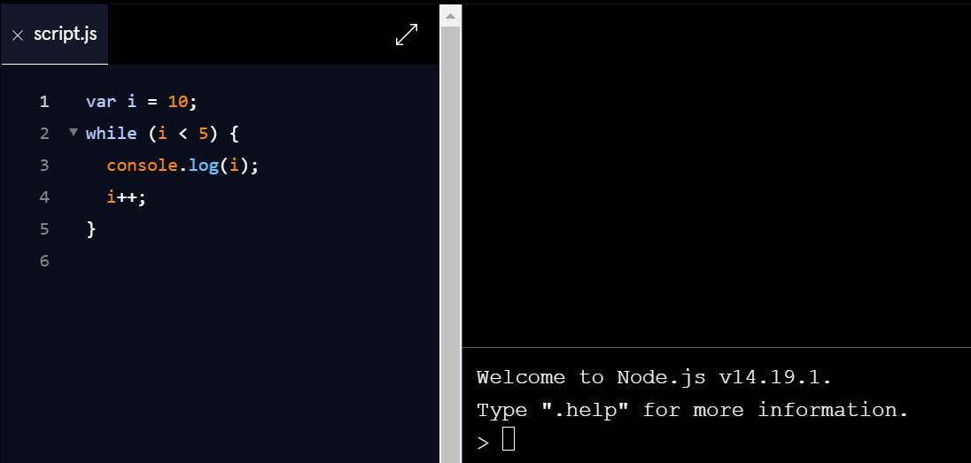

Since the condition (10 < 5 ) is not true, the while loop is not executed.

**What will the output here?**

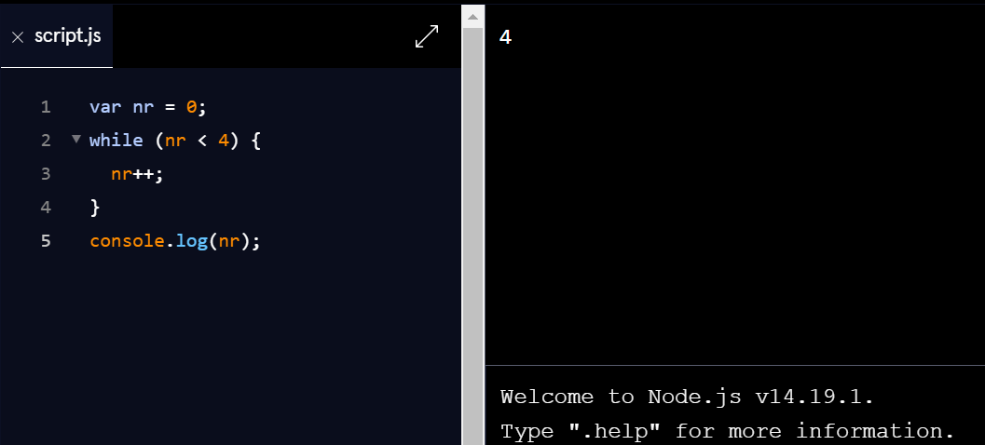

The while statement creates a loop that executes the specified statement if the condition is true. The condition is evaluated before the statement is executed.

The given while loop is executed when the nr is less than 4. When the nr begins to be equal to or greater than 4, the while loop ends. As a result we get the number of all iterations.

**What will the output here?**

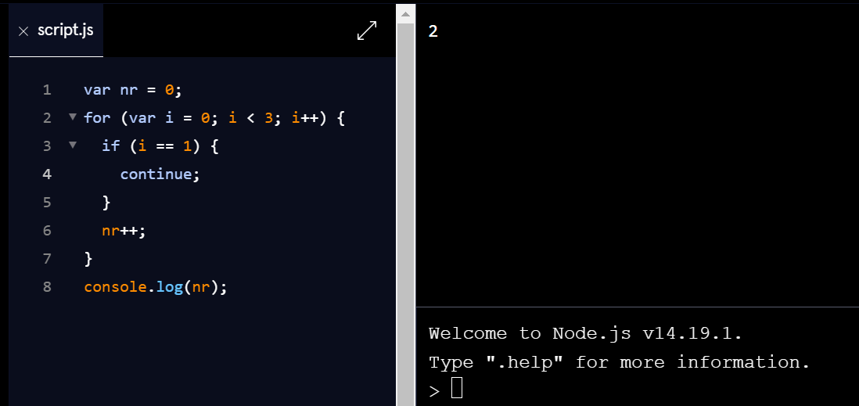

The continue statement skips one iteration and continues the loop in the next iteration. Variable nr is incremented in the first (i = 0) and third (i = 2) interactions. The second (i = 1) iteration is skipped. If variable i is equal to 3, the loop ends at (i < 3).